Reception Class 2019-2020
Term | Topic
Autumn 1 | Super Me, Super You
Autumn 2 | The Gruffalo &  Let‛s  Celebrate
Spring 1 | Once Upon a Time
Spring 2 | Journeys &Transport  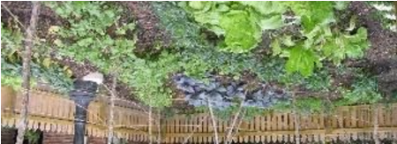  Growing & Habitats
Summer 1
Summer 2 | Safari 