What my Child is Learning…
Maths
In Maths this term, we will be reviewing all the topics we have covered so far in year 2 including addition and subtracting, partitioning, money, place value, multiplication and division. We will do one week on time and reading scales and spend some time working on reasoning and problem solving.
English
Year 2 will be writing their own creation story based on the West African tale: The Fire Children. We will also be writing information texts about how chocolate is made and looking at the origins of Cocoa production in Ghana, We will also be writing instruction of how to plant seeds to tie in with our Science topic.

Chocolate
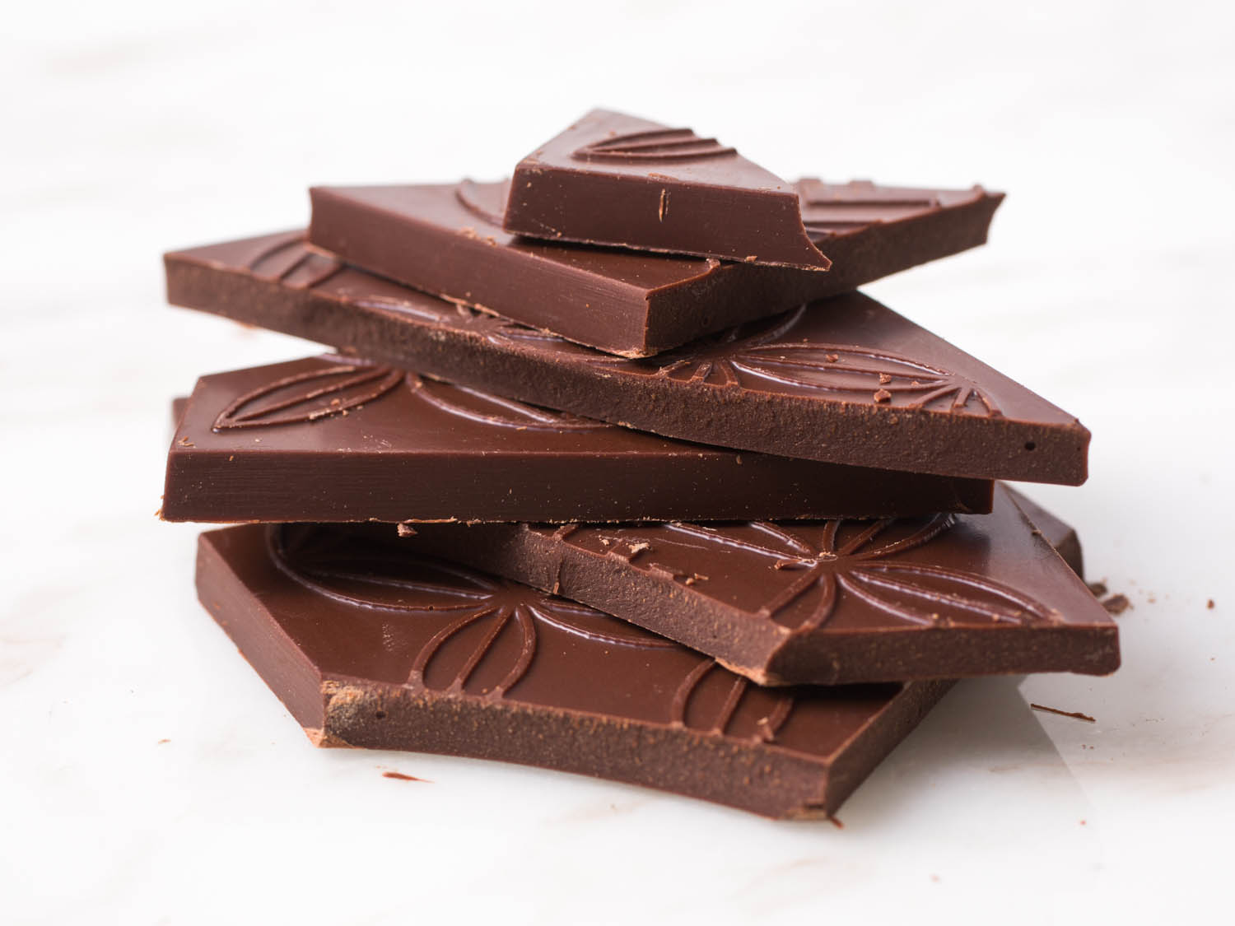
Summer 1
Art/DT
Children will create their own paintings of the African savannah looking at colour and form. Children will create animal silhouettes against a sunset background.
PE
In PE this term, children will be swimming and doing athletics. In athletics, they will be learning how to sprint and throw.
Geography
Children will be learning about place knowledge, comparing our lives with those who live in Ghana. We will be learning about cocoa crops and Fairtrade for farmers. We will be learning how we can help to support cocoa farmers in Ghana by the types of chocolate we buy.
Science
The children will learn about plants. We will be planting seeds and helping them to grow, observing and testing how different conditions affect their chances of survival. We will be observing the plants in our local area and recapping on identifying different trees by their leaves.
PSHE
Children will be learning about medicines, when we take them and who is responsible for them. The children will learn to recognise signs and symbols that help keep us safe.
RE
In RE, year 2 will be learning about Sikhism. They will learn how Sikhism stresses the importance of doing good actions rather than merely carrying out rituals. They will learn where Sikhs worship, the special Sikh book, and special days/festivals.
Music
This term we will be continuing to learn the recorder. Children will learn to play simple songs using the notes BA and G. We will be listening to a specific style of Music and appraising the different elements we can hear.
Websites:
www.phonicsplay.co.uk
www.topmarks.co.uk
www.crickweb.co.uk
www.mymaths.co.uk

